Maple Hills PTA E Bulletin
10.5.2025
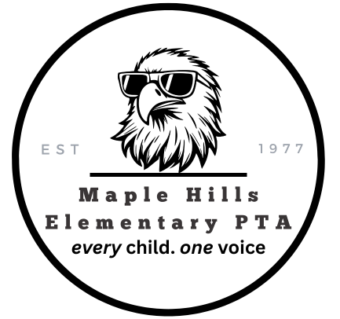
👀 Coming Up!
Restaurant Nights:
- Jay Berry’s - October 13th
- Drum Roll Wine - November 1st
- Chipotle - December 6th
✔️Brown Bear Carwash Ticket Fundraiser – Ends October 14th
✔️Seattle Reign Soccer Fundraiser - October 10th
✔️PTA General Membership Meeting – October 15th

How to Update Your Information & Student Information on the PTA Website
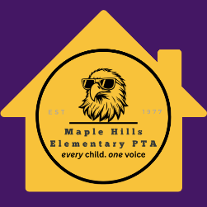
Keeping your account and student information up to date is important, especially now that we are tracking Eagle Reader minutes (which started October 1st)!
Follow these quick steps to update your information:
- Log in to the PTA Website.
- On the left-hand side menu, click My Account.

- Scroll down to Students.
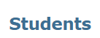
- On the far right of your student’s name, click the pencil icon ✏️ (Edit).
- This will take you to your student’s edit screen, where you can update or add information.
- Save your changes before leaving the page.
✅ That’s it! Your students’ information is now updated and ready for Eagle Reader tracking.

⚽ Maple Hills Night with the Seattle Reign! ⚽
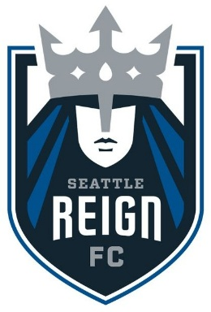
Join your Maple Hills friends and family for a fun night of soccer under the lights at Lumen Field as we cheer on the Seattle Reign!
📅 Date: Friday, October 10th
⏰ Time: 7:30 PM kickoff
📍 Location: Lumen Field, 800 Occidental Ave S, Seattle, WA 98134
Tickets are just $25 each ($29.12 with fees), and $5 from every ticket goes directly to Maple Hills PTA! Parking passes are also available for $36.04.
We have a special Maple Hills section in the 100 level seats, so you will be right in the action with other Eagles fans!
🎟️ Purchase your tickets and parking passes here:
https://www.gofevo.com/event/Maplehills2

🚗✨ Brown Bear Car Wash Tickets on Sale!

Brown Bear Car Wash Ticket on sale NOW until October 14.
Support Maple Hills PTA while keeping your car sparkling clean! Quantities are limited.
Shop here
Pick up: Wednesday, October 15th, 7:00pm at the PTA General Membership Meeting at Maple Hills Elementary.

🦅 Order Your Eaglewear Spirit Wear Today!
Show your school spirit with awesome new styles available in both child and adult sizes!
Salel Ends Soon! Shop Here
📅 On Sale: Sept 19 – Oct 10
🛍 Order Deadline: Oct 10 (no late orders accepted)
📦 Orders Distributed at School: Oct 24
⚠️ All sales final—no refunds or exchanges.
Don’t miss out! Order your EagleWear today and rep Maple Hills with pride! 💜
❓ Questions? Email MossyTrailsCo@gmail.com

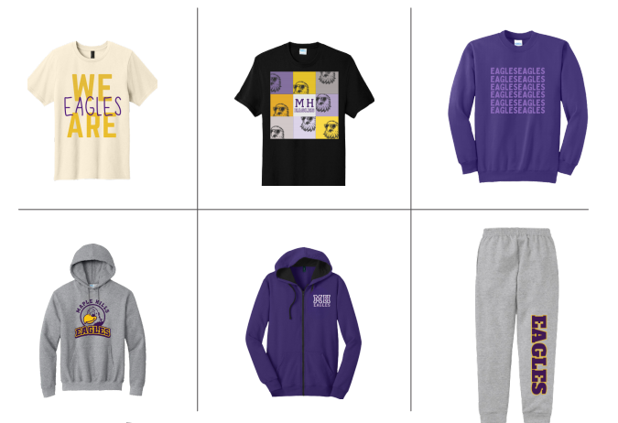

Hearing & Vision Screening Volunteers Needed!
We need your help to support this important event at Maple Hills!
📌 Sign up here: SignUpGenius
✅ Reminder: All volunteers must be approved through the ISD Volunteer process: Apply Here

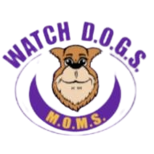
This year we’re expanding our beloved Watch D.O.G.S. (Dads of Great Students) program to include Watch M.O.M.S. (Moms of Marvelous Students), because positive role models of all kinds make a big impact at Maple Hills!
Volunteers help with recess games, lunchroom fun, traffic flow, hallway support, and more while being a visible, caring presence for all students.
Shift Sign Up: https://www.signupgenius.com/go/10C0544AEA722A6FB6-59228257-watch#/

📚 Eagle Reader Program
(insert logo)
Reading builds confidence and success and it should be fun too!
The Eagle Reader Program, funded by Maple Hills PTA, encourages students to read or listen to books outside of school and celebrate their progress.
Check your student’s purple folder for this months paper calendar or ➡️ Enter minutes HERE! Learn more about the program
✨ How to participate:
- Log your student’s reading minutes on the PTA website.
- Meet the monthly grade-level goal = earn a free book the following month at the Eagle Reader Clubhouse.
- Didn’t hit the goal? Minutes roll over, earn a book after two months of effort!
➡️ Enter minutes and learn more at maplehillspta.com

🎨 Reflections Art Contest Update
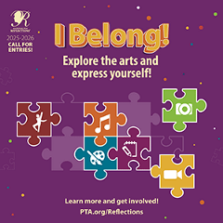
This year’s theme is “I Belong!”
Students in pre-K through grade 12 create original works of art in response to an annual theme. Students can submit original works of art in one, or more, of the available arts categories: Dance Choreography, Film Production, Literature, Music Composition, Photography, and Visual Arts.
Please stay tuned for additional information coming home, but in the meantime, here are some key dates:
- October 30: All projects must be submitted to the Reflections team
- November 3-7: Maple Hills Elementary PTA will judge pieces if more than 12 entries are submitted
- November 19: Final Maple Hills entries are submitted to the Reflections Council
Every student can shine, and entries can be recognized at local, state, and even national levels!
The PTA is still in need of a Reflections Chair Person and volunteers to make this a success!
📩 For entry packets + rules: email maplehillsartdocents@gmail.com
🔗 Learn more: WA State PTA Reflections

🍔 Food, Fun & Fundraising 🍔
Jay Berry’s Café!
Join us for our 2nd Restaurant Night of the year at Jay Berry’s Café - a Maple Hills community favorite!
Monday, October 13th, 4:00 – 9:00 PM
16341 Renton Issaquah Rd SE, Renton, WA 98059
Important: Be sure to mention Maple Hills Fundraiser so that 20% of your bill will be donated to the Maple Hills PTA.
Drum Roll Wine! Adults Night Out
Sip, snack, and support Maple Hills at Drum Roll Wine!
Saturday, November 1st, 4:00 – 9:00 PM
911 S 3rd St, Renton, WA 98057
Enjoy wine tastings, a glass of wine, and light snacks (outside food welcome too!).
25% of all bottles purchased to-go during this time will be donated to the Maple Hills PTA. Perfect for holiday gifting!
Chipotle Night!
Wrap up your weekend with burritos, bowls & more at Chipotle – Issaquah!
Saturday, December 6th, 4:00 – 8:00 PM
775 NW Gilman Blvd, Issaquah, WA 98027
25% of your order will be donated back to Maple Hills PTA when you:
- Show the flyer (paper or digital) OR
- Mention “Maple Hills PTA Fundraiser” before paying OR
- Use code H9GNQ9P when ordering online or in the Chipotle app.

PTA General Membership Meetings – Save the Dates!
📅 October 15, 2025 | January 21, 2026 | April 22, 2026
🕖 7:00–8:00 PM
📍 Maple Hills Elementary Library
✅ All are welcome - you don’t need to be a PTA member to attend, share your ideas, and join the conversation.
✅ PTA members - your vote matters on important items such as the budget, officers, and standing rules.
Beyond the business, these meetings are a great opportunity to meet other families, connect with school staff, and strengthen our community, all in support of our students’ success.
✨ New this year: Pick up your purchased Brown Bear Car Wash tickets at the meeting and be entered to win a door prize!

ParentWiser Event: Cultural Conflicts – Two Worlds, One Home
Monday, October 20, 2025 | 6:30 – 8:00 PM
The Circle | 160 NW Gilman Blvd, Suite 326, Issaquah
The Maple Hills PTA is sharing this event on behalf of the Issaquah PTA Council & Parent Wiser.
Raising teens in multicultural families can be both rewarding and challenging. Differences in language, values, and identity often spark tension. Join speakers Cloe Zeng (The Gottman Institute) and Dr. Fangying Stephanie Shi (licensed clinical psychologist) for a powerful talk on building bridges across cultural divides with clarity, compassion, and connection.
📅 Event Details:
- Cultural Conflicts: Two Worlds, One Home
- Date/Time: Monday, October 20, 2025 | 6:30 – 8:00 PM
- Location: The Circle, Issaquah
- Registration: http://bit.ly/4nWBf65
Learn more and share with your community: Facebook Event

💜 Employer Matching = Double the Impact! 💜
Did you know many companies will match your donations or volunteer hours to the Maple Hills PTA at no extra cost to you? It’s an easy way to double support for our students, teachers, and programs.
✔ Companies like Amazon, Apple, Boeing, T-Mobile and Microsoft participate.
✔ Check if your employer matches at: maplehillspta.com/Page/PTA/Employer%20Matching
✔ Questions or need our W9? Email treasurer@maplehillspta.com
Every match makes a difference for our Eagles! 🦅

🌟 Call for a FACE Representative! 🌟
If you’re passionate about helping every family feel connected and engaged at Maple Hills, this could be a great role for you!
The Issaquah PTSA Council is looking for each school to have a Family and Community Engagement (FACE) representative, and Maple Hills needs one!
The FACE Rep helps build a welcoming, inclusive school community by connecting families, staff, and the PTA. This role also represents our school at district-wide FACE and DEI (Diversity, Equity & Inclusion) committee meetings.
📅 District Meeting Schedule
- FACE + DEI Joint Meeting: October 17, 2025 – 10:30am @ ISD Admin Building
- FACE Meeting: February 6, 2026 – 10:30am @ ISD Admin Building
- FACE + DEI Joint Meeting & Potluck: May 29, 2026 – 11:00am @ ISD Admin Building (outside)
👉 Sign up to attend district meetings here: FACE & DEI Meeting Sign-up
📄 Learn more about the role here: FACE Rep Job Description

Community Clothing Closet Update
The Issaquah Food Bank is no longer hosting its annual coat drive, but a new non-profit formed by a few Council members is stepping up to fill the need! The Community Clothing Closet will help ensure families in our area still have access to warm clothing and coats as the weather turns colder.
📍 Upcoming Event at Pickering Barn (1720 10th Ave NW, across from Costco):
- Monday, October 20 – Clothing Donation Day
Drop off your gently used or new items between 11 am – 7 pm.
- Tuesday, October 21 – Free Shopping Day
Shop the racks for free between 2 pm – 6:30 pm. Bring your family, friends, and neighbors!
Learn more and get involved:
🌐 communityclothingcloset.org
📘 Community Clothing Closet on Facebook

💜 Join & Volunteer with Maple Hills PTA! 💜
We’ve got amazing events planned and need YOUR help, especially for Reflections, Fall Celebration (Nov. 7), Yearbook, Advocacy, and FACE Chairs.
Sign up at Volunteer Central and renew your membership at maplehillspta.givebacks.com/shop. Scholarships available, email president@maplehillspta.com.

Unsubscribe Email: Communications@maplehillspta.com

